**The Elemental Tree of Humanity**

The colossal tree of humanity and warmth

Was once anchored deep into the land of peace,

Breathing the breeze of compassion and mirth,

Expanding to the ether of boundless increase;

Irrigated and healed by the cosmic ethereal river,

And nourished by the strength of Phoebus’ fire.

Soon time marched into the epoch of modernity.

When crafty flames of human ambitions and greed

Parched the whimpering river of spirituality.

The euphony of joy became a dirge of hatred.

Peace was soaked from the mourning wake,

Afore humanity scorched humanity at stake;

And the tree of humanity withered and seared,

Lamenting over the perishing land of peace.

-Aadityaamlan Panda

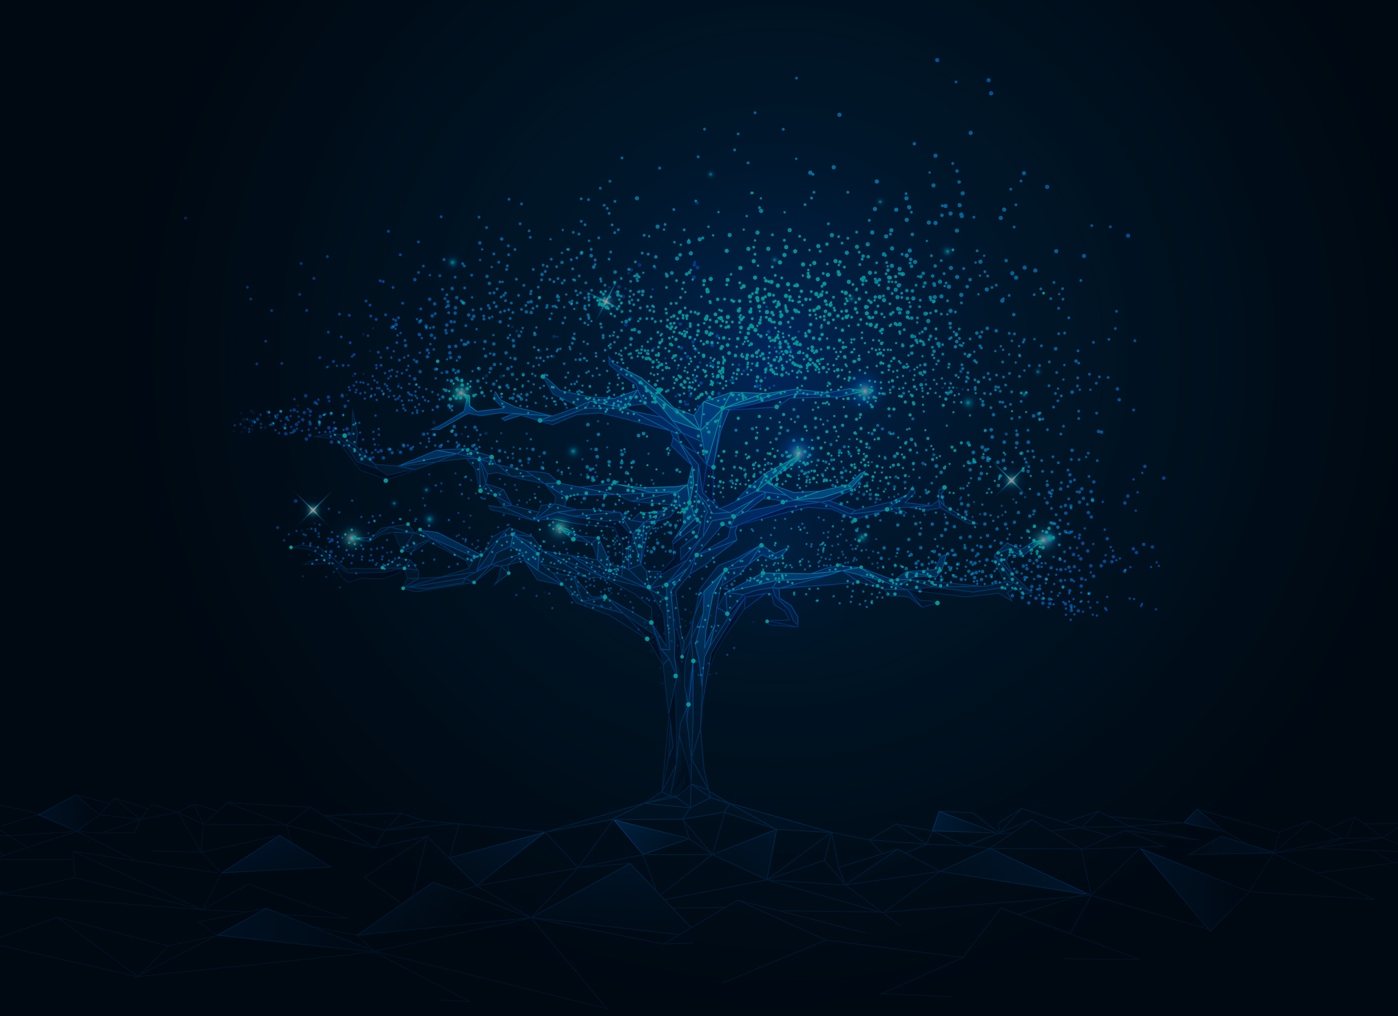

**The Elemental Tree of Humanity**

The colossal tree of humanity and warmth

Was once anchored deep into the land of peace,

Breathing the breeze of compassion and mirth,

Expanding to the ether of boundless increase;

Irrigated and healed by the cosmic ethereal river,

And nourished by the strength of Phoebus’ fire.

Soon time marched into the epoch of modernity.

When crafty flames of human ambitions and greed

Parched the whimpering river of spirituality.

The euphony of joy became a dirge of hatred.

Peace was soaked from the mourning wake,

Afore humanity scorched humanity at stake;

And the tree of humanity withered and seared,

Lamenting over the perishing land of peace.

-Aadityaamlan Panda